Step 1: Log in to https://ams.ashoka.edu.in/
Step 2: Student Support Hub
Step 3: Advising Hub: Office Hours
Step 4: Choose the ‘Office of Career Development’ in the “Meeting”
Step 5: Click on “Book Now” and write the purpose of the meeting to book the office hours
(In case you wish to visit the CDO office, go to the 1st floor of AC02, and find class adjacent to the subway OR beside AC02 113)

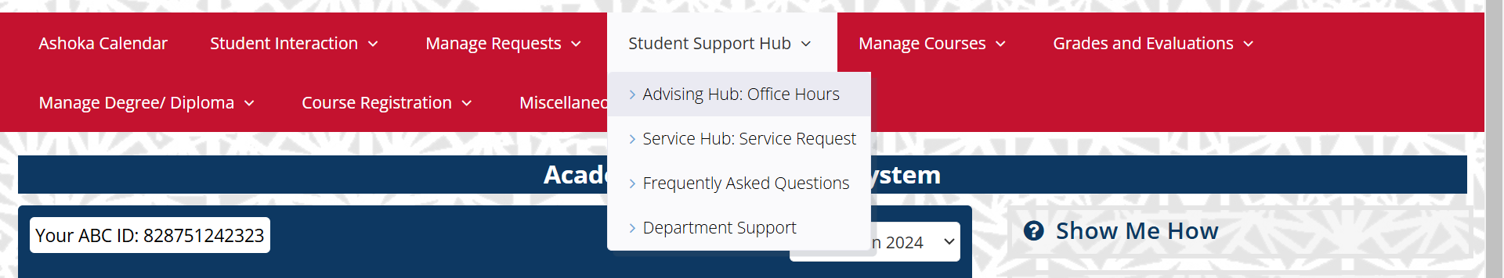
STEP 2+3

\

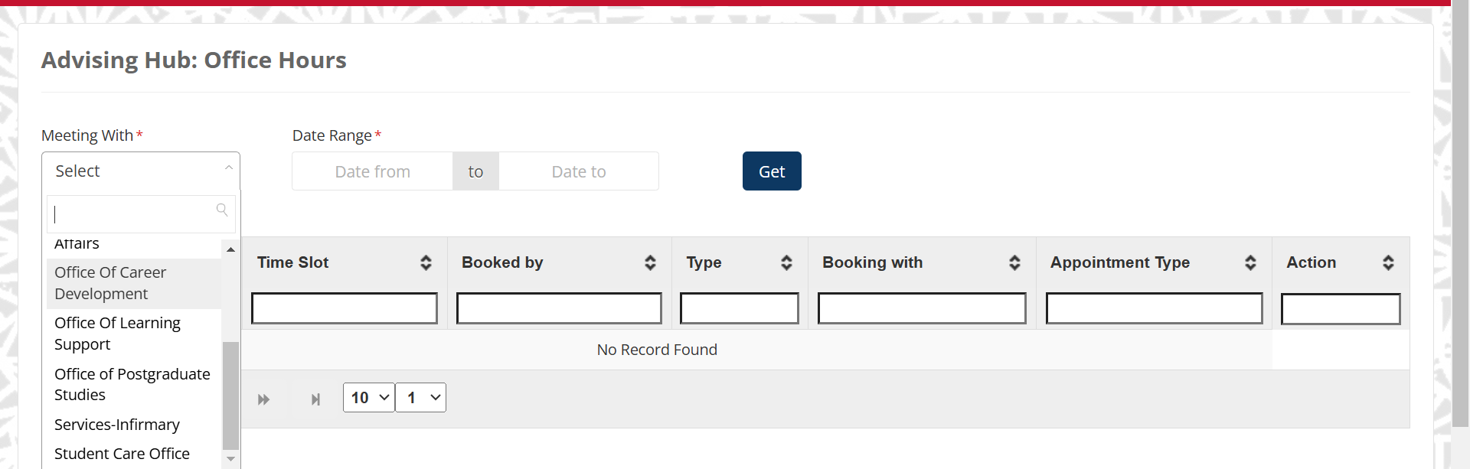
STEP 4

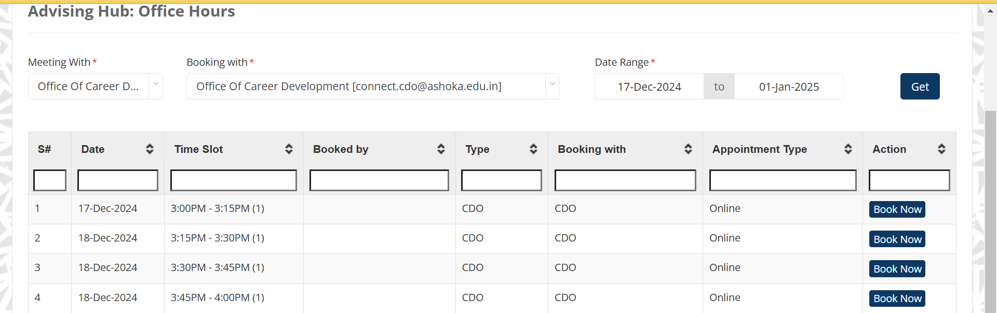
STEP 5

